**1.(a) Write a program in assembly language to print single character on screen.**  
**CODE**

ORG 100h

MOV DX, OFFSET msg_input

MOV AH, 09h

INT 21h

MOV AH, 01h

INT 21h

MOV CL, AL

MOV DX, OFFSET msg_output

MOV AH, 09h

INT 21h

MOV DL, CL

MOV AH, 02h

INT 21h

MOV AH, 4Ch

INT 21h

msg_input DB 'Enter a letter: $'

msg_output DB 0Dh, 0Ah, 'The entered value is: $'

END

**OUTPUT:-**

**1.(b) Write an assembly language program to convert an upper-case letter to the**

**corresponding lower-case letter.**

**CODE:**

ORG 100h

MOV DX, OFFSET msg_input

MOV AH, 09h

INT 21h

MOV AH, 01h

INT 21h

MOV BL, AL

CMP BL, 'A'

JL NotUpperCase

CMP BL, 'Z'

JG NotUpperCase

ADD BL, 20h

MOV DX, OFFSET msg_output

MOV AH, 09h

INT 21h

MOV DL, BL

MOV AH, 02h

INT 21h

JMP EndProgram

NotUpperCase:

MOV DX, OFFSET msg_error

MOV AH, 09h

INT 21h

EndProgram:

MOV AH, 4Ch

INT 21h

msg_input DB 'Enter an uppercase letter: $'

msg_output DB 0Dh, 0Ah, 'The lowercase letter is: $'

msg_error DB 0Dh, 0Ah, 'Error: Not an uppercase letter! $'

END

**OUTPUT: for not entering uppercase letter.**

**OUTPUT: for entering uppercase letter.**

**2. (a) Write a program in assembly language to print multiple characters on screen.**

**CODE:**

ORG 100h

MOV DX, OFFSET msg_input

MOV AH, 09h

INT 21h

MOV BX, OFFSET buffer

MOV CX, 0

ReadLoop:

MOV AH, 01h

INT 21h

CMP AL, 0Dh

JE DoneReading

MOV [BX], AL

INC BX

INC CX

JMP ReadLoop

DoneReading:

MOV DX, OFFSET msg_output

MOV AH, 09h

INT 21h

MOV BX, OFFSET buffer

PrintLoop:

MOV DL, [BX]

CMP DL, 0Dh

JE EndProgram

MOV AH, 02h

INT 21h

INC BX

JMP PrintLoop

EndProgram:

MOV AH, 4Ch

INT 21h

msg_input DB 'Enter any number of characters (press Enter to finish): $'

msg_output DB 0Dh, 0Ah, 'The entered characters are: $'

buffer DB 256 DUP(0)

END

**OUTPUT:**

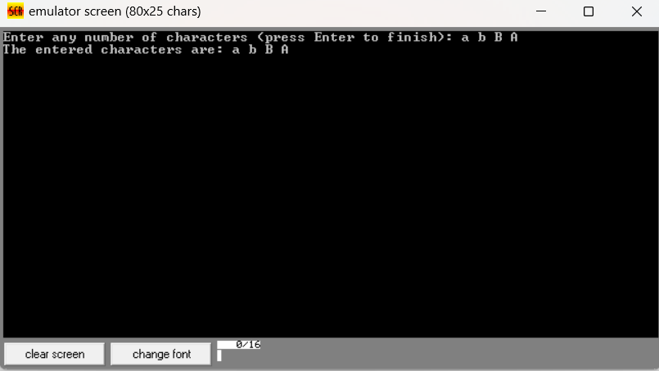

**2.(b) Write an assembly language program to convert a lower-case letter to the**

**corresponding upper-case letter.**

CODE:

ORG 100h

MOV DX, OFFSET msg_input

MOV AH, 09h

INT 21h

MOV AH, 01h

INT 21h

MOV BL, AL

CMP BL, 'a'

JL NotLowerCase

CMP BL, 'z'

JG NotLowerCase

SUB BL, 20h

MOV DX, OFFSET msg_output

MOV AH, 09h

INT 21h

MOV DL, BL

MOV AH, 02h

INT 21h

JMP EndProgram

NotLowerCase:

MOV DX, OFFSET msg_error

MOV AH, 09h

INT 21h

EndProgram:

MOV AH, 4Ch

INT 21h

msg_input DB 'Enter a lowercase letter: $'

msg_output DB 0Dh, 0Ah, 'The uppercase letter is: $'

msg_error DB 0Dh, 0Ah, 'Error: Not a lowercase letter! $'

END

**OUTPUT: for not entering lowercase letter.**

**OUTPUT:** **for entering lowercase letter**.